SIOP® LESSON PLAN

Date: October 24, 2013 Grade/Class/Subject: U.S. History (9-12)
Unit/Theme: Early Indigenous Culture and the Impact of Spanish Exploration in the Southwestern U.S.
Standards(s): | U.S. History Standard: 6120-03 Students will understand the changes caused by European exploration in the Americas.  Language Art Standard 3: (Inquiry/Research/Oral Presentation): Students will understand the process of seeking and giving information in conversations, group discussions, written reports, and oral presentations:
Content Objective(s): | 6120-0301 Explore the lives among Indigenous Americans nations prior to European exploration of the New World.  6120-0302 Analyze the reasons for European exploration.  6120-0303 Assess the impact of European exploration on African slaves and American Indian nations
Language Objective(s): | Objective 1 (Processes of Inquiry): Use the process of inquiry to draw conclusions.  Objective 2 (Written Communication of Inquiry): Write to evaluate information and to make recommendations.  Objective 3 (Oral Communication of Inquiry): Make informative and persuasive presentations using visual aids/technology.

Key Vocabulary
- boom  - casualties  - conquistador  - cuadrillero  - deposits  - desertion  - encomendero  - expedition | - friar  - inscription  - lodes  - maimed  - skirmish  - Acoma Pueblo  - Baja California | - El Camino Real de Tierra Adentro  - El Morro  - El Paso  - Española  - Jornada del Muerto  - Kansas  - La Villa de Santa Fe | - Los Charcos de Perrillo  - Ohkay-Owingeh  - Quivira  - Rio de Chama  - Rio Grande  - Rio de Ojo Caliente  - Soccorro  - Yunque-Ouinge

Supplemental Materials
Photographs:  - Various pueblos and ruins  - El Morro Inscription  - Governor’s Palace | Documents & Maps:  - Oñate map  - N. America Map  - El Camino Real Map | Videos:  - PBS: When Worlds Collide  - POV: The Last Conquistador  - Visit with Respect | Artifacts:  - Dried corn cobs  - Split twig figure  - Acoma pottery

Top of Form
SIOP Features
Preparation  ^{Adaptation of Content}  ^{Links to Background}  ^{Links to Past Learning}  ^{Strategies Incorporated}  Integration of Processes  ^{Reading}  ^{Writing}  ^{Speaking}  ^{Listening} | Scaffolding  ^{Modeling}  ^{Guided Practice}  ^{Independent Practice}  ^{Comprehensible Input}  Application  ^{Hands-on}  ^{Meaningful}  ^{Linked to Objectives}  ^{Promotes Engagement} | Grouping Options  ^{Whole Class}  ^{Small Groups}  ^{Partners}  ^{Independent}  Assessment  ^{Individual}  ^{Group}  ^{Written}  ^{Oral}
Motivation (building background):
Day 1: What was daily life like for early Indigenous People of the Southwest? (Provide students with photographs of artifacts and on-site locations, and if possible hands-on artifacts.)
Day 2: In your own words and using notes from evidence and research, describe early Puebloan culture, include references to each piece of evidence you’ve examined. Write one question you have.
Day 3: Tracing the Oñate expedition along the El Camino Real, what evidence indicates why they moved north to settle near Española, N.M.? (Provide copies of Oñate’s map, and maps of the Southwest. Provide copies of diary excerpts and dates when the expedition arrived at certain locations.)
Day 4: What impact did the Oñate Expedition have on the daily lives of early Indigenous People?
Day 5: Was the Oñate Expedition good or bad? Support your ideas with at least three main points.
Presentation (language & content objectives, comprehensible input, strategies, practice, feedback):
Day 1: Write about what life might have been like for Indigenous People and Spanish explorers during this period of time and provide at least two examples from the artifacts provided. They will include at least five “why” or “how” questions to research, discuss, or investigate further throughout the lesson.
Practice/Application (meaningful activities, interaction, strategies, practice/application, feedback):
Day 1: Students will write questions about the day-to-day existence of early Puebloan Cultures using evidence from photographs, and artifacts.
Day 2: Students will research questions from several sources and write a one-page description of what life might have been like in the Southwest using notes from group discussions.
Day 3-4: Students will read excerpts from translated documents and use original maps from early Spanish exploration to locate and draw key landmarks on a blank map including El Camino Real. Watch excerpt from When Worlds Collide
Day 5: Students will examine images from Sanctuario de Chimayo including religious iconography, a schoolhouse at Rancho de Las Golondrinas, and read an article on the Oñate expedition.
Day 6-7: Students will spend 10 minutes discussing whether they believe early Spanish contact was good or bad in small groups, and then write about their own conclusions using evidence they’ve gathered through notes.
Review/Assessment (review objectives and vocabulary, assess learning):
- Descriptive essay on early Puebloan Culture (25 pts.)
- Notes from class discussions and gathering of evidence (50 pts.)
- Persuasive essay to support whether or not they believe early exploration is “good or bad” (25 pts.)

Extension:
Option 1: Research two other explorers (Spanish, French, and English) during this period of time and compare the expeditions with that of the Oñate expedition.

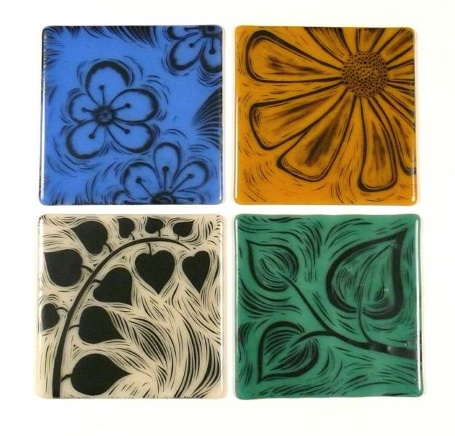 | Option 2: Students can make a paper model of a Pueblo Pot, or a coil pot with sgraffito designs engraved in the outer walls that can be fired in a conventional oven.
Bottom of Form
Top of Form
Bottom of Form

