Aggy | Mathew Ashby | Lydia Broadnax | Edith Cumbo
Eve | Johnny | Gaby Burwell | Gowan Pamphlet
Thomas Jefferson | Patrick Henry | Lord Dunmore | Benedict Arnold
Catherine Blaikley | William Byrd | Robert Carter | Richard Charlton
Richard Charlton | Sarah “Sally” Charlton | Edith Cumbo | Anne Geddy
James Geddy Jr. | John Greehow | Grissell Hay | Samuel Henley
Alexander Hoy | Marquis de Lafayette | Richard Henry Lee | George Mercer
George Wythe | Edmund Pendleton | Alexander Purdie | Captain Tom Step
John Montour | Robert Carter Nicholas | Benjamin Powell | Edmund Randolph
Sir John Randolph | John  “The Tory” Randolph | St. George Tucker | John Robinson
Ann Wager | Benjamin Waller | Lady Susannah Beverly Randolph | Elizabeth (Betty) Harrison Randolph

Name ________________________________________________________________________ Period _______________

Colonial Character Research

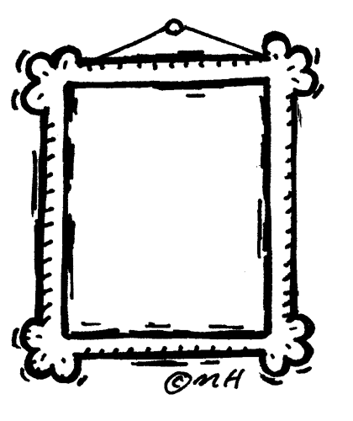Directions: You will create a character sketch for someone who lived during the Colonial period using the resources located at www.history.org . Click on “History” (top left corner). The link will take you to find all the webpages you need to complete People, Places, Life, Clothing, Trades, of the assignment.

PEOPLE

Character Name ____________________________

Occupation ________________________________

Age ______________________________________

Draw a depiction of your character in the picture frame

Your character has just been given a journal. Read the biography about your character and determine 8 main points others should know about that person. Create your character’s journal entry by including those 8 points as if you were your character. Do not copy the information from the text. Summarize the information in your own words. Make sure you write in complete sentences.

PLACES – You will visit the Community, Family Homes and The Government. Choose 3 places to visit within each section. Describe 1. What goes on there? 2. Who goes there? 3. Why is it significant to the community?
Community - _________________________________________

Community - _________________________________________

Community - _________________________________________
The Community is an interesting place for a picture! Draw a picture of one of the places you visited for your scrapbook.

Family Homes - _________________________________________

Family Homes - _________________________________________

Family Homes - _________________________________________
After visiting 3 family homes, choose one that has architectural features/characteristics you think is/are most interesting and draw a picture of your interpretation.

The Government - _________________________________________

The Government - _________________________________________

The Government - _________________________________________

The Government buildings are worthy to be commemorated by a stamp. Choose one government building you “visited” and draw a picture to commemorate the building.

LIFE - Choose “Colonial Social Classes” to learn about the role social classes played in colonial life. Write a brief description to remind yourself who belonged in each social class.

Enslaved Field Hands - _______________________________________________________________________________

Enslaved House Servants – ____________________________________________________________________________

Free Blacks – _______________________________________________________________________________________

Farmers – _________________________________________________________________________________________

Middling – _________________________________________________________________________________________

Gentry – ___________________________________________________________________________________________

Put a star by the “sort”/class to which your character belongs.

CLOTHING
Click on “Anatomy of a Gown.” You will need to click on the items so you are familiar with their names. Determine which item that you are grateful is not a part of your modern wardrobe - “Leave in the Past,” and one that is the most similar to your modern wardrobe – “Currently Colonial.” You will need to do the same for “Anatomy of a Suit.”

Anatomy of a Gown Anatomy of a Suit

Leave in the Past____________________________ Leave in the Past____________________________

Currently Colonial ____________________________ Currently Colonial____________________________

Now go to “Dressing the Part” – Answer the following questions.

- In dressing the Gentry, which item is first? _______________________________________________

- What is the last item to dress the Household Slave? ________________________________________

- What is the second item to dress the Middle Sort? _________________________________________

- What is the last item to dress the Field Slaves? ____________________________________________

TRADES – You will visit 4 different trades that existed during the Colonial period. Define what 1. A tradesman in the selected trade produced, 2. What kind of tools did a person in the trade need? 3. What kind of skills were necessary to be your selected trade? Answer the prompts in complete sentences. When you have finished reading the description of your selected trade, draw a picture that incorporates the following shape to depict the trade or a tool used during the colonial period.

Trade _______________________________

Trade _______________________________

Trade _______________________________

Trade _______________________________

Colonial Character Research
People  - Research  (accurate, interesting, evidence of understanding)  - Directions  (followed directions completely)  - Picture  (accurate, neat, colored)  - Grammar  (capitalize, punctuate complete sentences) | Trades  - Research  (accurate, interesting, evidence of understanding)  - Directions  (followed directions completely)  - Pictures  (accurate, neat, colored)  - Grammar  (capitalize, punctuate complete sentences)  - Creativity  (demonstrates creative thought – beyond the obvious)
Places  - Research  (accurate, interesting, evidence of understanding)  - Directions  (followed directions completely)  - Pictures  (accurate, neat, colored) | Clothing  - Research  (accurate, interesting, evidence of understanding)
Life  - Research  (accurate, interesting, evidence of understanding) | TOTAL /45

Colonial Character Research (Teacher Sheet)
People  - Research ____/3  (accurate, interesting, evidence of understanding)  - Directions ____/3  (followed directions completely)  - Picture ____/3  (accurate, neat, colored)  - Grammar ____/2  (capitalize, punctuate complete sentences)  /11 | Trades  - Research ____/3  (accurate, interesting, evidence of understanding)  - Directions ____/3  (followed directions completely)  - Pictures ____/3  (accurate, neat, colored)  - Grammar ____/2  (capitalize, punctuate complete sentences)  /13  - Creativity ____/2  (demonstrates creative thought – beyond the obvious)
Places  - Research ____/4.5  (accurate, interesting, evidence of understanding)  - Directions ____/4.5  (followed directions completely)  /15  - Pictures ____/6  (accurate, neat, colored) | Clothing  - Research ____/3  (accurate, interesting, evidence of understanding)  /3
Life  /3  - Research ____/3  (accurate, interesting, evidence of understanding) | TOTAL /45

