Lesson Plan using “Building Students’ Historical Literacies”

Name: Kayla Vernon Subject: U.S. History II Length: 1 45-minute class period

- Utah State Core Curriculum Standard(s)
Standard 5
Students will understand the significance of the American Revolution in the development of the United States.
Objective 1
Analyze what ideas and events led to the Revolutionary movement.
- Explore the events leading to the outbreak of armed conflict between the American
colonies and Great Britain.
- Lesson Objective(s)
- Students will be able to source and corroborate several political cartoons from the time period of the American Revolution.
- Preparation
- Teacher
- Packets of Cartoons
- Graphic Organizer
- Student
- None
- Technology Use
- None
- Instructional Procedures
- Self-Start: How did the colonists feel about the American Revolution? Did they all feel this way? How do you know?
  - Discuss how we always here the very patriotic side of the war, but what about those who didn’t want war, or who sympathized with the British, etc.
- Put the students in groups and hand each group one of the political cartoons as well as the graphic organizer. Have them gather as much information as possible and then jigsaw the groups and have them share with each other what they learned.
  - Cartoons taken from http://ww2.wyomingcityschools.org/~zollerjw/revolution.html
  - How to Analyze a Political Cartoon as a Historical Source from Nokes, Jeffery D., Building Students’ Historical Literacies, Routledge Press, New York, pg. 44.
- End the class by passing out post-it notes and having them write down their favorite thing they learned that day and stick it up on the board. With whatever time is left, go over them with the class.
- Accommodation(s) for Diverse Learner(s) (Differentiation)
- Intrapersonal—working with groups
- Visual—political cartoons
- Linguistic—writing

- Evaluation/Assessment of Student Progress
- Pre-Assessment
- Self-Start
- Formative Assessment
- Worksheet
- Summative Assessment
- Questions from this lesson will appear on the unit test

Name _______________________________ Date _________________ Period __________________

Political Cartoons of the Revolutionary War

This cartoon was drawn by Benjamin Franklin in the very early days of the Revolutionary War. It was done shortly after the battles of Lexington and Concord. Pay special attention to the letters along the snake's body. In order to understand the meaning of this cartoon, consider who the audience might have been.
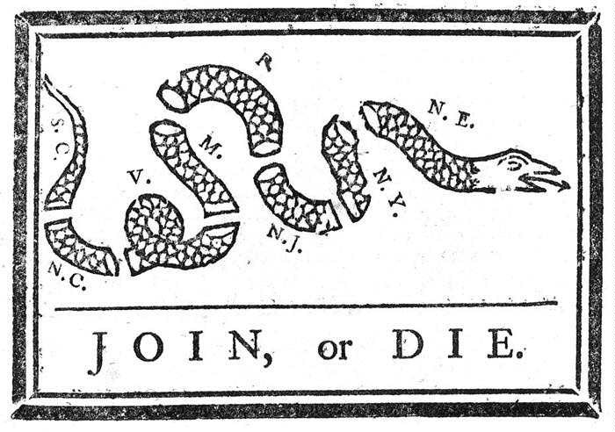
Step One: Identify your initial reaction
- What does this make you feel?

- What do you think it means?

- Who do you think the author intended as their audience?

Step Two: Identify the symbols
- Are there any labels? If so, describe what they mean.

- Identify universal symbols.

- Attend to subtle symbols.

- Consider symbolic speech/captions.

- Interpret symbolic actions.

Step Three: Identify the relationship between symbols
- Attend to physical location of important symbols

- Interpret actions connecting symbols

Step Four: Interpret the author’s methods and message
- Identify exaggerations.

- Gather information about the artist.

- Consider the artist as a source (what influence does that have?)

- Summarize the artist’s stance.

Step Five: Critique the cartoon
- Consider flaws in the artist’s logic.

- Consider information the artist has omitted. Do you think it was left out on purpose, forgotten, or unknown to the artist?

- Find contrasting opinions (where could you even look for this?! Try a textbook, or the internet, but look for primary sources!)

- What is your final critique of the cartoon?

Name _______________________________ Date _________________ Period __________________

Political Cartoons of the Revolutionary War

This cartoon shows several members of the Sons of Liberty standing in front of a tree marked "Liberty Tree". The unhappy person kneeling in the center of the picture appears to be covered in feathers. The Sons of Liberty are pouring a liquid into his mouth from a container marked "tea". To better understand this picture make sure you can identify the man who is kneeling.
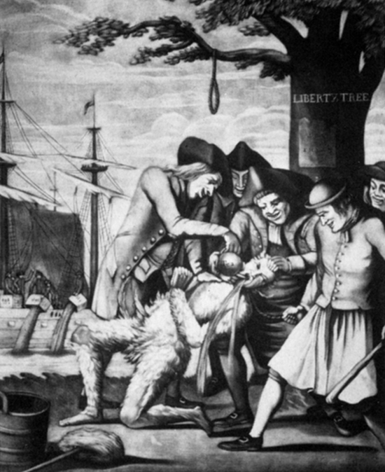

Step One: Identify your initial reaction
- What does this make you feel?

- What do you think it means?

- Who do you think the author intended as their audience?

Step Two: Identify the symbols
- Are there any labels? If so, describe what they mean.

- Identify universal symbols.

- Attend to subtle symbols.

- Consider symbolic speech/captions.

- Interpret symbolic actions.

Step Three: Identify the relationship between symbols
- Attend to physical location of important symbols

- Interpret actions connecting symbols

Step Four: Interpret the author’s methods and message
- Identify exaggerations.

- Gather information about the artist.

- Consider the artist as a source (what influence does that have?)

- Summarize the artist’s stance.

Step Five: Critique the cartoon
- Consider flaws in the artist’s logic.

- Consider information the artist has omitted. Do you think it was left out on purpose, forgotten, or unknown to the artist?

- Find contrasting opinions (where could you even look for this?! Try a textbook, or the internet, but look for primary sources!)

- What is your final critique of the cartoon?

Name _______________________________ Date _________________ Period __________________

Political Cartoons of the Revolutionary War

This cartoon is entitled "Bostonians in Trouble". It shows people in a cage that is suspended from a tree labeled "Liberty Tree". Below the cage, people are handing fish up to the people who are trapped.
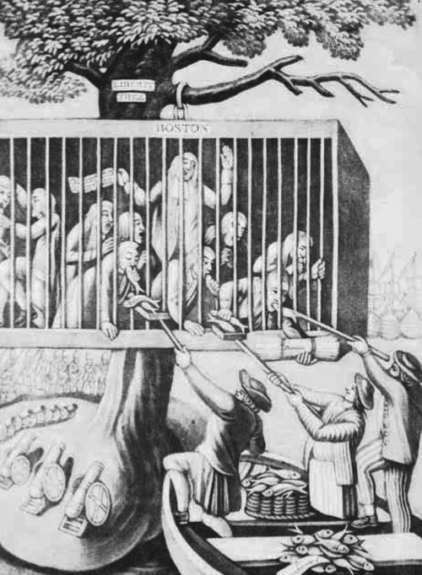

Step One: Identify your initial reaction
- What does this make you feel?

- What do you think it means?

- Who do you think the author intended as their audience?

Step Two: Identify the symbols
- Are there any labels? If so, describe what they mean.

- Identify universal symbols.

- Attend to subtle symbols.

- Consider symbolic speech/captions.

- Interpret symbolic actions.

Step Three: Identify the relationship between symbols
- Attend to physical location of important symbols

- Interpret actions connecting symbols

Step Four: Interpret the author’s methods and message
- Identify exaggerations.

- Gather information about the artist.

- Consider the artist as a source (what influence does that have?)

- Summarize the artist’s stance.

Step Five: Critique the cartoon
- Consider flaws in the artist’s logic.

- Consider information the artist has omitted. Do you think it was left out on purpose, forgotten, or unknown to the artist?

- Find contrasting opinions (where could you even look for this?! Try a textbook, or the internet, but look for primary sources!)

- What is your final critique of the cartoon?

Name _______________________________ Date _________________ Period __________________

Political Cartoons of the Revolutionary War
This illustration was done later in the Revolutionary War as the colonists were beginning to gain momentum. They had already won two major victories over British troops. The illustration is entitled the "American Rattle Snake". The snake is saying, "Two British armies have I beaten and room for more I've got behind." The sign posted over the third empty coil says, "room for rent for military gentlemen."
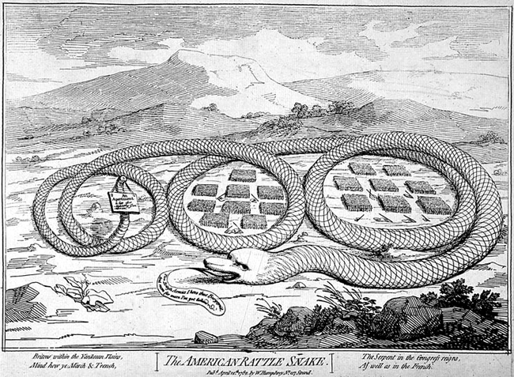

Step One: Identify your initial reaction
- What does this make you feel?

- What do you think it means?

- Who do you think the author intended as their audience?

Step Two: Identify the symbols
- Are there any labels? If so, describe what they mean.

- Identify universal symbols.

- Attend to subtle symbols.

- Consider symbolic speech/captions.

- Interpret symbolic actions.

Step Three: Identify the relationship between symbols
- Attend to physical location of important symbols

- Interpret actions connecting symbols

Step Four: Interpret the author’s methods and message
- Identify exaggerations.

- Gather information about the artist.

- Consider the artist as a source (what influence does that have?)

- Summarize the artist’s stance.

Step Five: Critique the cartoon
- Consider flaws in the artist’s logic.

- Consider information the artist has omitted. Do you think it was left out on purpose, forgotten, or unknown to the artist?

- Find contrasting opinions (where could you even look for this?! Try a textbook, or the internet, but look for primary sources!)

- What is your final critique of the cartoon?

Name _______________________________ Date _________________ Period __________________

Political Cartoons of the Revolutionary War
The Stamp Act caused anger and resentment among the colonists. Finally, Parliament repealed the Stamp act in 1766. In this cartoon we see a funeral procession to the tomb of the Stamp Act. The man who created the Stamp Act in Parliament, George Grenville is shown carrying a child's coffin that says "Miss American Stamp Act born 1765 died 1766".
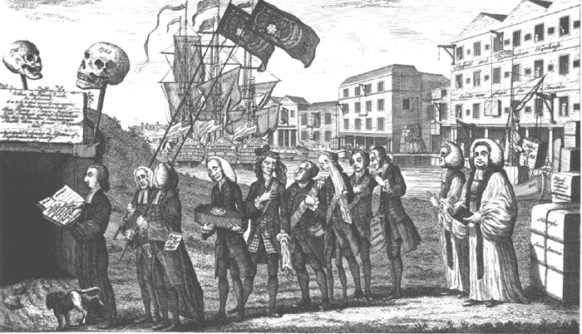

Step One: Identify your initial reaction
- What does this make you feel?

- What do you think it means?

- Who do you think the author intended as their audience?

Step Two: Identify the symbols
- Are there any labels? If so, describe what they mean.

- Identify universal symbols.

- Attend to subtle symbols.

- Consider symbolic speech/captions.

- Interpret symbolic actions.

Step Three: Identify the relationship between symbols
- Attend to physical location of important symbols

- Interpret actions connecting symbols

Step Four: Interpret the author’s methods and message
- Identify exaggerations.

- Gather information about the artist.

- Consider the artist as a source (what influence does that have?)

- Summarize the artist’s stance.

Step Five: Critique the cartoon
- Consider flaws in the artist’s logic.

- Consider information the artist has omitted. Do you think it was left out on purpose, forgotten, or unknown to the artist?

- Find contrasting opinions (where could you even look for this?! Try a textbook, or the internet, but look for primary sources!)

- What is your final critique of the cartoon?

Name _______________________________ Date _________________ Period __________________

Political Cartoons of the Revolutionary War
This cartoon shows the King of England pointing a gun at a man who represents the colonies. A member of Parliament is pointing at this man and saying, "I give you that man's money for your use. The colonists responds by saying, "I will not be robbed!" Behind him a woman representing England is blindfolded and is about to stumble into a pit that is labeled, "the Pit prepared for others".
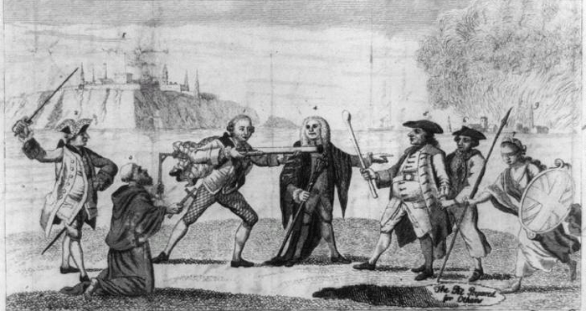

Step One: Identify your initial reaction
- What does this make you feel?

- What do you think it means?

- Who do you think the author intended as their audience?

Step Two: Identify the symbols
- Are there any labels? If so, describe what they mean.

- Identify universal symbols.

- Attend to subtle symbols.

- Consider symbolic speech/captions.

- Interpret symbolic actions.

Step Three: Identify the relationship between symbols
- Attend to physical location of important symbols

- Interpret actions connecting symbols

Step Four: Interpret the author’s methods and message
- Identify exaggerations.

- Gather information about the artist.

- Consider the artist as a source (what influence does that have?)

- Summarize the artist’s stance.

Step Five: Critique the cartoon
- Consider flaws in the artist’s logic.

- Consider information the artist has omitted. Do you think it was left out on purpose, forgotten, or unknown to the artist?

- Find contrasting opinions (where could you even look for this?! Try a textbook, or the internet, but look for primary sources!)

- What is your final critique of the cartoon?

